Heritage information sheet

Body sealing - MGB Roadster and MGB GT
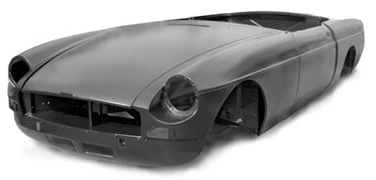
In response to customer feedback, Heritage bodies no longer have seam sealer applied, allowing owners the choice when preparing their cars for concours d'elegance or competition use. This information sheet has been produced as a guide for those owners who wish to seam seal their bodyshell to the original factory specification prior to applying coats of primer.
It is recommended that the sealer is applied to the bodyshell using a caulking gun and then worked into the seam with a short bristled brush.
Suitable products include any air drying sealant for home application or, if the work is carried out by a professional painting company, a product suitable for the company's paint spray oven and curing temperature is required.
1. Rear wheel arches  The left hand wheel arch is shown. Repeat application to the right hand side.  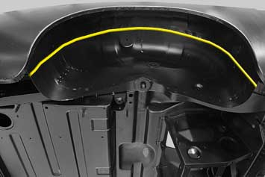 | 2. Front wheel arches  The right hand wheel arch is shown. Repeat application to the left hand side.  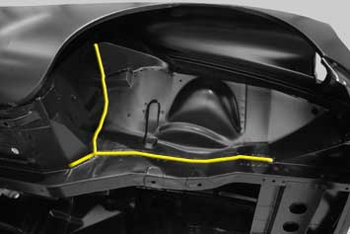
3. Inside the boot  Apply to both sides as shown.  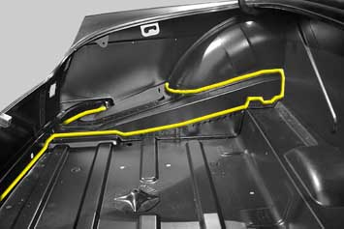 | 4. Engine bay  Apply to both sides as shown.  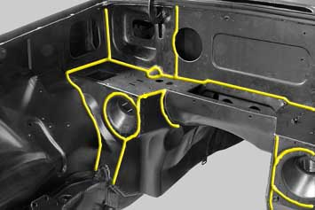
5. Transmission tunnel  Apply to both sides of the tunnel, down into the footwell (right hand side illustrated).  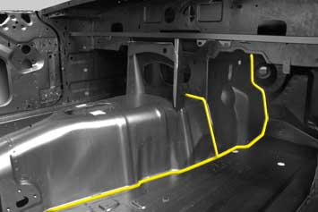 | 6. Dash side  Apply to each dash side (left hand side shown).  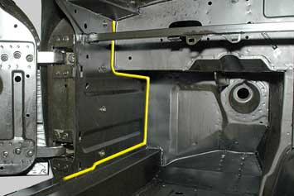
7. Rear interior
Apply to both sides as shown(left hand side illustrated).

